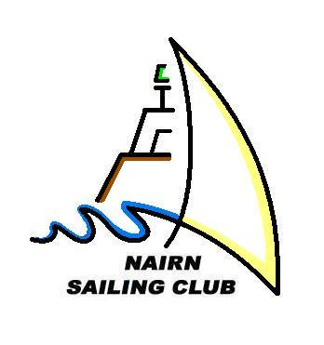
NAIRN SAILING CLUB
The Clubhouse, Harbour Street, Nairn, IV12 4PH
http://www.nairnsailingclub.org

MEMBERSHIP APPLICATION/SUBSCRIPTION FORM 2024
Return to: NSC Membership Secretary:
Email – nscmembership@outlook.com

Your Details: For family memberships both adult names can be listed here; juniors are listed over the page. The club is keen to use email – please write email addresses clearly

Name(s)
Address
Postcode
Landline |  | Mobile
Email(s):

If you prefer to make payment via your online banking facility, the Club’s bank account details are:
Sort Code 80-09-17 Account 00759165 (Bank of Scotland, 73 High Street, Nairn).
Please reference “your surname/subs”, and inform the Membership Secretary that payment has been made.
Category | Rate | Amount Paid | Payment Method
Family Membership includes 2 adults and any of their children aged 18 and under | £100*
Single Membership | £80*
Out of Port Membership (total family cost) | £25
Friends of NSC *at the discretion of the committee | £25
Intermediate Membership (aged 18-22 full time education, or a student) | £25
Junior Membership (13 to 17) | £20
Under 12s ( must be supervised by an adult in any club activity, adult to be covered by club insurance, will have to pay £20) | £20 per child  £20 per adult

* ½ price membership for the 1st year

Boat Name | Boat Type  Cruiser/Dinghy | Is Your Boat Insured  Y/N | Length in Metres

Parents/Guardians: to be completed and signed if membership includes juniors under 16 years. All children under 16 must be accompanied by a Parent/Guardian or a responsible adult who is over 16.

I have sole responsibility for my children/wards and do not expect the club to exercise supervision or control in any way.

Signed Parent/Guardian _______________________________________

Date _____________________

Please fill in email addresses and mobile numbers if you wish to be included.

Name

Club dinghy session charge – dinghy sailors only

To cover the cost of general repairs and support boat fuel the club asks for a £25 one off payment per participant using a club dinghy to cover the season. Please include this in your subs payment.

Consent for use of images of children

I grant to the club officials without payment the right in perpetuity to make, use and show any motion pictures, still pictures and live, taped or filmed television of or relating to events held by the club. I have read and understood the Conditions of Use. I agree to notify the club officials of any relevant changes in my child’s circumstances.

I confirm that my child is not under a court order.

Signed: (participant) .....................................................................................................

Signed: (parent/guardian)...............................................................................................

Name: (please print) ........................................................................ Date: .......................

